# EXPERIMENT – 4

## Aim:

Perform various point processing operations like negative, log and power law transformation on an image

## Software used:

MATLAB

## Theory:

Negative transformation:

The second linear transformation is negative transformation, which is invert of identity transformation. In negative transformation, each value of the input image is subtracted from the L-1 and mapped onto the output image.

## Logarithmic transformations:

Logarithmic transformation further contains two type of transformation. Log transformation and inverse log transformation.

The log transformations can be defined by this formula

s = c log(r + 1).

## Power – Law transformations:

There are further two transformation is power law transformations, that include nth power and nth root transformation. These transformations can be given by the expression:

s=cr^γ

This symbol γ is called gamma, due to which this transformation is also known as gamma transformation.

**Output:**

Image Negative: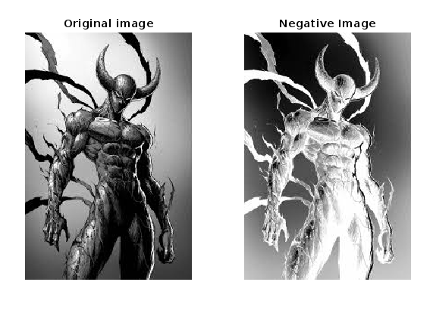

Code:

Neg = imread("test1.jfif");

subplot(1, 2, 1),

imshow(neg);

title("Original image");

L = 2 ^ 8;

neg = (L - 1) - neg;

subplot(1, 2, 2),

imshow(neg);

title("Negative Image")

Log Transformation:

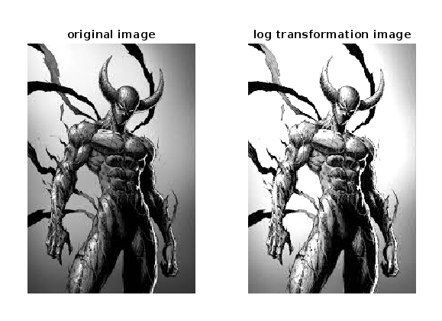

Code:

img1 = imread('test1.jfif'); % Read the image

d = double(img1)/255; % Normalized Image

c = 2; % Constant

t = c*log(1 + (d)); % Log Transform

subplot(1,2,1)

imshow(img1)

title('original image');

subplot(1,2,2)

imshow((t))

title('log transformation image');

Power Law Transformation:

Code:

I=imread('card9.png');

% To read image

figure,imshow(I)

p=rgb2gray(I);

% To convert RGB image to gray image(normalised image)

p=double(p);

figure,imshow(p/255)

[rowi,coli]=size(p);

r=0:1:255;

gamma=0.5;

c=1.5;

s=c*r.^gamma;

out=zeros(rowi,coli);

plot(r,s)

for k=1:256

for i=1:rowi

for j=1:coli

if p(i,j)==r(k)

out(i,j)=s(k);

end

end

end

end

figure,imshow(uint8(out))

